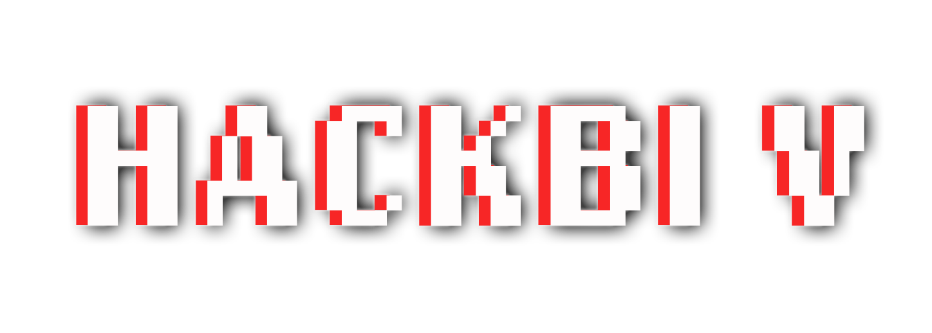

Python Workshop – John Olson

Prerequisites:

* VSCode Downloaded
* Python Downloaded
* (Guides for both in Github

Workshop Overview:

* What is VSCode?
  + VSCode is an IDE (Integrated Development Environment), basically a glorified text editor like Microsoft Notepad or TextEdit on Mac, but with special tools and extensions to help you write and run your code.
* What is Python?
  + Python is one of today’s most popular programming languages
  + Since it is a relatively new language, it has simple syntax, which makes it fairly easy to learn the basics
  + It is most popularly used for data analysis and scientific research purposes, but can be really be applied to any situation
* Making a Python file
  + Create a new folder on your computer wherever you want to work
  + In the folder, create a new file and name it helloworld.py
  + Now, open the file in VSCode
  + Add a line that says print(“Hello World”)
  + Run your code
* Variables
  + A variable is pretty much a symbol that represents a value
  + For example, if you type a = 1, the variable a now has the value 1
  + If we run print(a), the console will print 1
* Data Types
  + We can do this with multiple ‘data types’ too
  + Although Python has many data types, the three most basic ones are 1) numbers (integers and floats), which can be either whole or decimal numbers, 2) strings, like “Hello”, which represent symbols, letters or words 3) Booleans, which represent True or False values, and written out as True and False.

Looking to learn more Python?

* A